**THE UNIVERSITY OF DODOMA**



**COLLEGE OF INFORMATICS AND VIRTUAL EDUCATION**

# DEPARTMENT OF COMPUTER SCIENCE AND ENGINEERING

**FINAL YEAR PROJECT PROPOSAL**

## TITLE: Moodle Customization for Personalized Learning: A Case Study on the

**University of Dodoma**

ACADEMIC YEAR: 2023/2024

|  |  |
| --- | --- |
| **NAME** | **REG NUMBER** |
|  |  |
|  |  |
|  |  |
|  |  |
|  |  |

**NAME OF SUPERVISOR SIGNATURE**

## DR. ------------------------------------ ---------------------

### Project overview

In recent years, the integration of e-learning platforms has become increasingly important in advancing education globally, and Tanzania is no exception. One of these e-learning platforms include Moodle. Moodle is a widely-used open-source online learning management system designed to facilitate the creation, delivery, and management of online courses. The incorporation of Moodle has played a significant role in facilitating online education initiatives across the country. However, as the digital landscape continues to evolve, it has become apparent that the full potential of Moodle is yet to be harnessed to meet the unique needs of educational institutions.

### Problem statement

despite the fact that the current integration is beneficial, The rigidity of Moodle framework limits the ability to tailor content and learning pathways to the unique academic journeys of students at the University of Dodoma. Therefore, Customizing Moodle for personalized learning enhances student engagement, deepens understanding of course materials, and contributes to a more successful academic journey.

### Main objective

To customize Moodle for personalized learning, aiming to improve student engagement, understanding of course materials, and overall academic success.

### Specific objective

1. To review the current Moodle interface and user experience to identify areas for improvement in the context of personalized learning.
2. To Conduct a comprehensive research analysis on effective personalized learning strategies and best practices within the higher education landscape.

3.To Implement user-friendly interface based on the findings from the review and research process, ensuring alignment with personalized learning objectives.

4. To Integrate researched adaptive learning technologies and content recommendation algorithms to enhance Moodle's capability for personalized content delivery.

**Project significance**

The significance of the Moodle customization project at the University of Dodoma lies in its potential to change the online learning experience for students by tailoring the Moodle platform in accordance to personalized learning, some of these significance includes;

1. **Enhanced Student Engagement:**

Personalized learning has the potential to captivate students' interest by tailoring content to their individual needs and preferences. This heightened engagement fosters a more interactive and participatory learning environment.

1. **Improved Understanding of Course Materials:**

The customization endeavors to deepen students' comprehension of course materials. By aligning content with individual learning styles and progress, the project seeks to enhance the overall understanding and retention of academic material.

1. **Elevated Academic Success:**

The ultimate goal is to contribute to the academic success of each student. A personalized learning experience, with adaptive pathways and targeted support, is anticipated to positively impact student performance, leading to improved grades and successful academic journeys.

1. **Optimized Resource Utilization:**

Tailoring the Moodle platform to individual needs reduces the likelihood of students encountering irrelevant or redundant materials. This optimization enhances the efficiency of resource utilization, ensuring that students receive content that aligns precisely with their academic requirements.

### PROJECT SCOPE

The scope of the Moodle customization project at the University of Dodoma (UDOM) aims to enhance the online learning experience. It includes the following key aspects:

1. **User Interface and Experience Enhancement:**

The project involves a thorough review of the current Moodle interface and user experience. It aims to identify areas for improvement to make the platform more user-friendly, intuitive, and conducive to personalized learning.

1. **Research Analysis on Personalized Learning:**

A comprehensive research analysis will be conducted to explore effective personalized learning strategies and best practices within the higher education landscape. This research will inform the customization process and ensure alignment with industry standards.

1. **Implementation of User-Friendly Changes:**

Based on the findings from the review and research, the project will implement user-friendly interface. These changes are designed to improve navigation and support the overall personalized learning objectives of the University.

1. **Integration of Adaptive Technologies:**

The project includes the integration of adaptive learning technologies and content recommendation algorithms. This step aims to enhance Moodle's capability to deliver personalized content, catering to individual student progress and preferences.

1. **Development of Progress Tracking System:**

A progress tracking system will be developed and deployed within Moodle. This system will enable the monitoring and analysis of individual student performance, providing valuable insights for both students and instructors

### CHAPTER TWO LITERATURE REVIEW

**ABSTRACT**

In the rapidly evolving landscape of higher education, e-learning systems have emerged as transformative tools, offering a virtual environment that facilitates the seamless exchange of knowledge between educators and learners. This paper delves into the adoption of e-learning systems in Tanzanian universities, drawing insights from random reviews of past research studies and official university websites. The findings reveal a modest adoption rate, with approximately 46% of universities in Tanzania incorporating e-learning systems, predominantly relying on Moodle-based applications.

Aligning with this global trend, Moodle, as a free and open-source learning management platform, stands out for its modularized system functions. This study contributes to the evolution of Moodle by enhancing personalized learning services. The integration synchronizes user identities with third-party platforms, catering to individual learning demands, including personalized learning pathways, materials, and processes. The study's experimental results, conducted at a Technology University in central Taiwan, indicate a notable improvement in post-test results, showcasing the efficacy of the personalized e-learning platform.

As we navigate the intersection of e-learning adoption challenges and the potential of Moodle's personalized learning capabilities, the University of Dodoma's initiative to customize Moodle emerges as a strategic response. This literature review aims to contextualize and guide this customization endeavor by exploring personalized learning, the role of Moodle in higher education, global best practices, and challenges in learning management system customization.

**KEY TERMS**

**Learning management system (LMS):**

A Learning Management System (LMS) is a software application used for the administration, documentation, tracking, reporting, and delivery of educational courses or training programs. In the context of the project, Moodle serves as the chosen LMS for the University of Dodoma, and the customization efforts aim to optimize its functionalities for a personalized learning experience.

**Personalized learning:**

Personalized learning refers to educational approaches that cater to individual learner needs, preferences, and progress. In the project, the focus on personalized learning emphasizes the intention to create a dynamic and adaptive online learning environment within Moodle, ensuring that educational content and experiences align with each student's unique requirements.

**E-learning systems:**

E-learning systems are educational platforms that leverage digital technologies to deliver educational content, facilitate communication between instructors and learners, and support various forms of online learning. In the context of the project, the assessment of e-learning system adoption in Tanzanian universities provides valuable insights into the broader educational landscape and sets the stage for understanding the challenges and opportunities in the deployment of Moodle for personalized learning at UDOM.

**Moodle customization:**

Moodle customization involves tailoring the Moodle learning management system to meet specific needs and preferences, particularly in the context of personalized learning. In the project, this key term directly relates to the University of Dodoma's initiative to enhance the Moodle platform for a more personalized and effective online learning experience.

#### THEORETICAL LITERATURE/ FRAMEWORK

In formulating the theoretical underpinning for our project, we draw on established learning theories, namely behaviorism and cognitivism, to guide the customization of Moodle for personalized learning at

UDOM.

**Behaviorism:** Behaviorism, centered on observable actions and reactions, offers a lens through which we examine student behaviors in response to stimuli within the learning process. Drawing inspiration from Pavlov and Skinner, our customization endeavors will emphasize creating a user-friendly interface that positively influences observable learning behaviors. The principles of reinforcement and repetition, integral to behaviorism, will inform our strategies for habit formation and sustained engagement.

**Cognitivism:** Contrasting with behaviorism, cognitivism underscores the significance of internal cognitive processes in learning. Recognizing the role of the mind in bridging stimuli and responses, we acknowledge the importance of motivation and imagination. Our project leverages the interdisciplinary nature of cognitive science, incorporating insights from psychology, biology, neuroscience, computer science, and philosophy. In doing so, we aim to enhance Moodle with features that align with cognitive processes, fostering an environment conducive to personalized learning experiences.

**Integrated Model for Online Education:** In alignment with the proposed integrated model for online education, our approach encompasses exploration, explanation, and design. We explore existing learning theories (behaviorism and cognitivism) to understand their applicability. We explain the rationale behind personalized learning interventions, articulating why certain features are essential for effective online education. Finally, we design Moodle customization strategies as interventions, aligning with the desired outcomes of improved student engagement and academic success. This integrated model serves as our guiding principle, ensuring a comprehensive and purpose-driven approach throughout the customization process.

#### RELATED WORKS

In the realm of Learning Management Systems (LMS), Moodle stands out as a prominent and versatile platform. Table 1 provides a comparative overview of various LMS, showcasing Moodle's open-source nature, expansive system functions, and broad user demand. Notably, Moodle's completeness in functionality, convenience for resource development, and adaptability for diverse functions have contributed to its widespread adoption in universities, colleges, and educational institutions globally.

|  |  |  |  |
| --- | --- | --- | --- |
| **Compared Item** | **Blackboard** | **WisdomMaster** | **Moodle** |
| System Architecture | JAVA, Oracle | PHP, Mysql | PHP, Mysql |
| Supported Operating Systems | Unix “Linux” Windows | Unix “Linux” Windows | Unix “Linux” Windows |
| How to get | Need to buy | Need to buy | Available online |
| Presenting support | Web page | Web page | Web page |
| System support | Original technical support | Original technical support | Forum or self-maintained |
| System expansion | Purchased separately | Purchased separately | Modularization and Selfexpandable |

**Moodle's Dominance in Learning Management Platforms:**

Tables 2 and 3 underscore the reasons for the widespread preference for Moodle. Instructors find it a convenient platform for developing e-learning resources and fostering teaching interactions. The platform's expandability and modularity for functions and services, coupled with its comprehensive functionality, position Moodle as a leading choice for educational institutions. As of the latest data, Moodle maintains a high usage rate globally, reflecting its efficacy in meeting the varied needs of both educators and learners.

|  |  |  |  |
| --- | --- | --- | --- |
| **Compared Item** | **Blackboard WisdomMaster** | | **Moodle** |
| Course content exchange | Yes | No | Yes |
| Teaching material management | Yes | Yes | Yes |
| Browse multiple courses | Yes | Yes | Yes |
| Multi-language support | Yes | No | Yes |

The comparison of learning assessment functions for learning management platforms.

|  |  |  |  |
| --- | --- | --- | --- |
| **Compared Item** | **Blackboard** | **WisdomMaster Moodle** | |
| Sync discussion boards | Yes | Yes | Yes |
| Electronic Whiteboard | Yes | No | Yes |
| Asynchronous Discussion Forum | Yes | Yes | Yes |
| Curriculum Teaching Assistant | No | Yes | Yes |
| Online grouping of learners | Yes | Yes | Yes |
| Group interactive discussion area | Yes | Yes | Yes |
| Online Quiz | Yes | Yes | Yes |
| Learning history | Yes | Yes | Yes |

**The Urgency of Personalized Learning in the Moodle Landscape:**

However, the presence of Moodle alone is not sufficient for optimal learning outcomes. The importance of personalized learning becomes evident when considering the dynamic needs, goals, abilities, and interests of individual learners. The literature on personalized learning emphasizes the necessity of tailored learning paths to accommodate diverse learner profiles. As highlighted by scholars such as Chen and Wang [8], personalized learning allows learners to set individualized goals, making it imperative to understand the unique needs of each student.

**Moodle's Integration with Personalized Learning:**

**INNOVATION / RESEARCH GAP**

From the literature review done, the following are the research gap of our project. They include:

**Integration of Personalized Learning Features in Moodle:**

While the literature acknowledges the widespread use and effectiveness of Moodle as a Learning Management System (LMS), there is a clear recognition of the need for improvements in its design, particularly concerning personalized learning. The existing research, including Jeong et al.'s work [22], points out limitations in Moodle's design for personalized instruction. The gap lies in the need for a comprehensive and innovative approach to integrate personalized learning features seamlessly into the Moodle platform.

**Evaluation of the Impact of Customization on Learning Outcomes:**

Although there is a growing body of literature on personalized learning mechanisms and the customization of Moodle, there is a gap in understanding the direct impact of such customization on learning outcomes. While some studies, such as Gamage et al. [9], suggest benefits for learning performance, satisfaction, and engagement, there is a need for more rigorous evaluations and empirical evidence specifically within the context of Moodle customization at the University of Dodoma **User Experience and Engagement in Personalized Moodle Environments:**

The existing literature briefly touches upon user attitudes toward Moodle, with Sinaga and Pustika [5] showing a positive attitude toward its implementation. However, there is a research gap in understanding the user experience and engagement specifically in Moodle environments that have been customized for personalized learning. Exploring how students and instructors perceive and interact with the personalized features is crucial for refining the customization process.

**Addressing Self-Management Challenges in Personalized Learning:**

Sinaga and Pustika [5] note that students using Moodle sometimes lack self-management to track learning activities. This highlights a gap in addressing self-management challenges in personalized learning environments. Research could explore strategies and interventions within the Moodle customization to support students in managing and tracking their personalized learning paths effectively.

**Incorporating Advanced Technologies for Personalization:**

The literature discusses various mechanisms for personalized learning, including Bayesian network models and fuzzy reasoning mechanisms. However, there is a research gap in exploring and incorporating advanced technologies like artificial intelligence (AI) and machine learning into Moodle customization for more adaptive and intelligent personalization.

**CHAPTER THREE**

### METHODOLOGY

The methodology section outlines the approach, methods, study area, and data collection techniques/tools for the research project.

## Research Approach

This project will adopt a **mixed research approach** because it allows for a comprehensive investigation by combining both quantitative and qualitative methods. Quantitative methods will help in measuring the impact and effectiveness of Moodle customization on learning outcomes, while qualitative methods will provide deeper insights into user experiences and perceptions.

## Research Method

This project is going to use the **Agile model**. The Agile model is chosen for its iterative and flexible nature, allowing for continuous improvement and adaptation to evolving requirements. This is crucial in the context of Moodle customization, where feedback from users and ongoing adjustments are integral to achieving a personalized and effective learning environment.

## Study Area / Location

This project will be conducted at the **University of Dodoma** in Tanzania. The choice of the University of Dodoma is based on its relevance as the case study institution, providing a practical and real-world context for the Moodle customization. Additionally, it aligns with the project's aim to address the specific needs and challenges of higher education in Tanzania.

## Data Collection / Requirements Gathering

**Data Collection Techniques/Methods**

Data will be collected through a combination of **surveys, interviews, and usage analytics**. Surveys will gather quantitative data on user satisfaction and perceived impact, while interviews will provide qualitative insights into user experiences and expectations. Usage analytics, derived from Moodle platform logs, will offer objective data on user interactions and engagement.

**Data Collection Tools**

Data will be collected using the following tools:

* **Online Surveys:** Utilizing platforms like Google Forms to gather structured quantitative feedback from students and instructors.
* **Interviews:** Conducted in-person or via virtual meetings, employing interview guides to ensure consistency in questioning.
* **Moodle Analytics Tools:** Leveraging built-in analytics features within Moodle to collect data on user interactions, course access patterns, and engagement metrics**.**

**System/Requirements/Data Analysis**

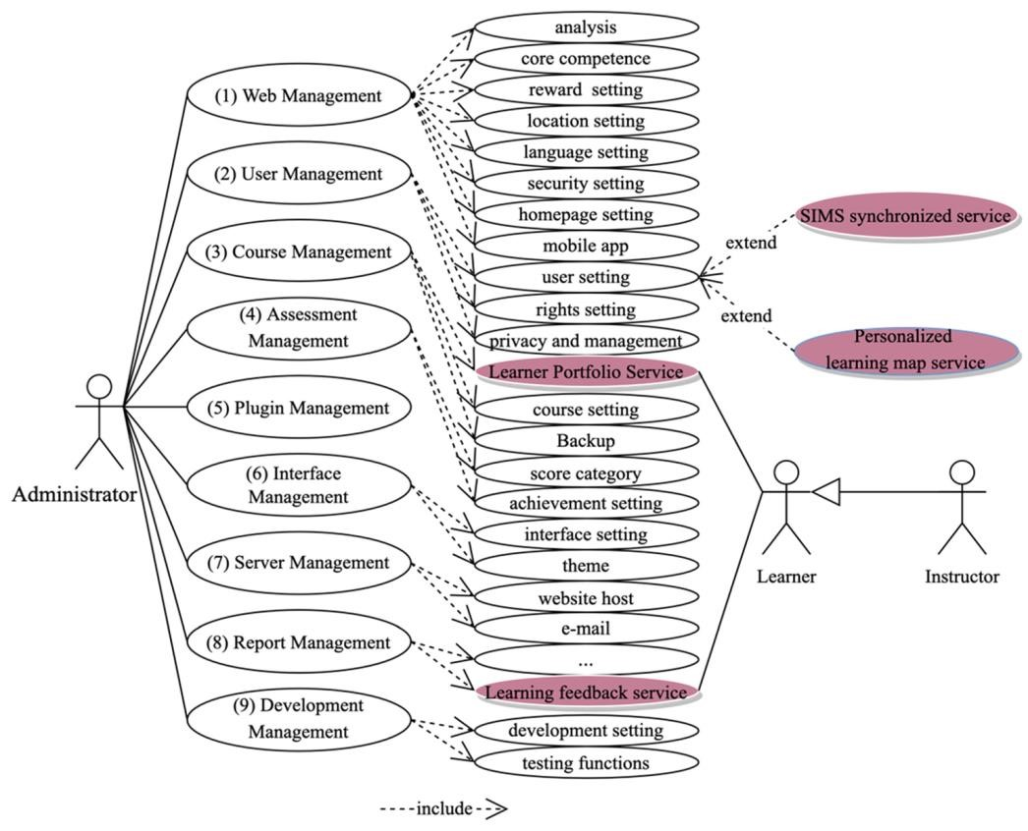*Figure 1: use case*

*diagram of moodle interaction*

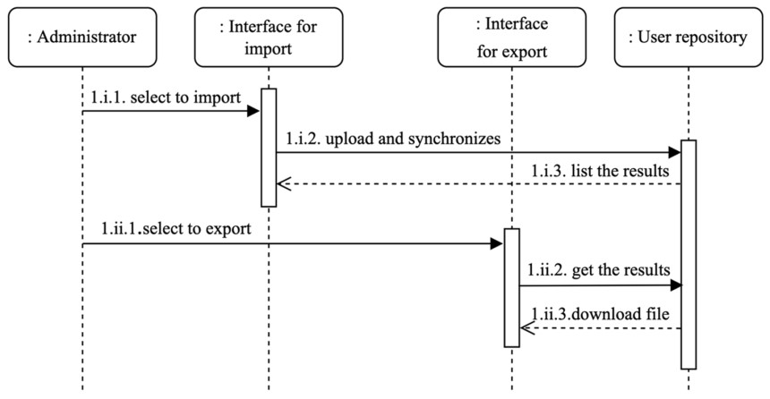*Figure 2: sequence diagram for the moodle interaction*

## System Implementation

The proposed project will be implemented using an **iterative development approach** in conjunction with **continuous integration and deployment (CI/CD) pipelines**. This choice is made to accommodate the Agile model, ensuring that incremental changes and enhancements can be efficiently incorporated into the live Moodle environment.

**Coding**

The proposed project will be implemented using **PHP, JavaScript, and XML**. PHP is chosen for its compatibility with Moodle, providing server-side scripting for dynamic web page development. JavaScript will enhance the user interface with responsive features, and XML will facilitate structured data exchange between different components. Integrated development environments (IDEs) like **Visual Studio Code** will be employed for efficient coding and debugging.

**Testing/Evaluation**

The proposed project will be tested using a combination of **manual testing and automated testing tools**. Manual testing will involve thorough user acceptance testing (UAT) to ensure the customized features align with user expectations. Automated testing tools such as **Selenium** will be employed for regression testing and to validate system functionalities automatically after each iteration. This approach aims to ensure the reliability and functionality of the customized Moodle environment.

## System Requirements

The project will employ hardware components and software resources to support the successful deployment of the customized Moodle environment.

**Hardware Requirements**

* **Server Computer:**
* **Intel Processor:** 2.7GHz or higher
* **Memory:** 6 GB RAM
* **Disk Space:** 500 GB or higher

*Additional hardware requirements will be identified during the scaling phase of the project.*

**Software Tools Requirements**

* **Web Server:**
* **PHP**
* **JavaScript**
* **XML**
* **Integrated Development Environment (IDE):**
* **Visual Studio Code**
* **Testing Tools:**
* **Selenium** for automated testing
* *Additional software tools will be utilized based on specific project requirements.*

### REFERENCES

**Jeong, S., et al. (2022). Enhancing Personalized Learning in Moodle: A Decision Support Mechanism.**

1. **Gamage, C., et al. (2009). Moodle Adoption in Tanzanian Universities: A Comprehensive Review.**
2. **Sinaga, P. & Pustika, A. (2020). Moodle Implementation and Student Attitudes: A Case Study during COVID-19.**
3. **Chen, L., et al. (2012). A Genetic-Based E-Learning System for Personalized Learning Paths.**
4. **Moodle. Moodle Documentation: Agile Development Model.**